**Lines of Code Metrics -** Tiago Francisco, nº 60749

It is a quantitative measurement for files that contains code from a computer programming language, in text form. The number of lines indicates the size of a given file and gives some indication of the work involved. It is used to quantify the software complexity.

LOC - Calculates the number of lines of code for each file type. Comments are counted, but whitespace is not.

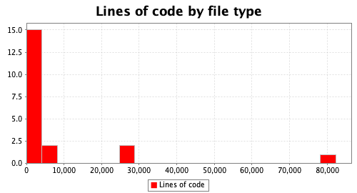

NLOC - Calculates the number of non-comment lines of code for each file type. Comment and empty lines are not counted.

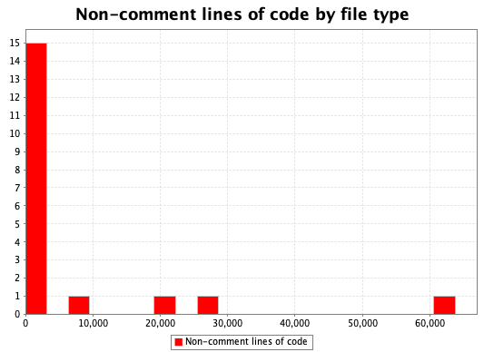

CLOC - Calculates the number of lines of code in each interface which contain comments. Anonymous inner classes are included in their containing class, while named inner classes are evaluated separately. Whitespace lines are not counted.

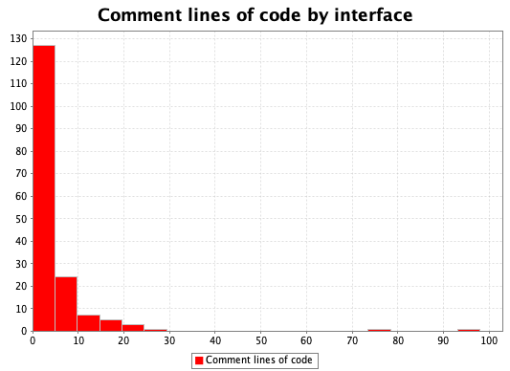

Comparing the histograms of LOC and NLOC we can see that there are a few differences between them. This means that there is almost no comments in the whole project which makes it challenging to understand some of the implementations.We can confirm that by analyzing the histogram of CLOC where the majority of the interfaces have minus than five lines with comments. That being said, we are in the presence of a code smell.